Alpha One Game Design Document (GDD)

ALPHA ONE

***‘Beyond Earth, to fight in the depths of hell.’***

– Roswell James Castaneda

This page: Table of Contents and Team Member Listing

|  |  |  |
| --- | --- | --- |
| Table of Contents  [1 Game Overview](https://n-xovwktmtjsnaxyc2mwes2xu7pohqedmdm6zjw5q-2lu-script.googleusercontent.com/userCodeAppPanel)  [2 High Concept](https://n-xovwktmtjsnaxyc2mwes2xu7pohqedmdm6zjw5q-2lu-script.googleusercontent.com/userCodeAppPanel)  [3 Unique Selling Points](https://n-xovwktmtjsnaxyc2mwes2xu7pohqedmdm6zjw5q-2lu-script.googleusercontent.com/userCodeAppPanel)  [4 Platform Minimum Requirements](https://n-xovwktmtjsnaxyc2mwes2xu7pohqedmdm6zjw5q-2lu-script.googleusercontent.com/userCodeAppPanel)  [5 Competitors / Similar Titles](https://n-xovwktmtjsnaxyc2mwes2xu7pohqedmdm6zjw5q-2lu-script.googleusercontent.com/userCodeAppPanel)  [6 Synopsis](https://n-xovwktmtjsnaxyc2mwes2xu7pohqedmdm6zjw5q-2lu-script.googleusercontent.com/userCodeAppPanel)  [7 Game Objectives](https://n-xovwktmtjsnaxyc2mwes2xu7pohqedmdm6zjw5q-2lu-script.googleusercontent.com/userCodeAppPanel)  [8 Game Rules](https://n-xovwktmtjsnaxyc2mwes2xu7pohqedmdm6zjw5q-2lu-script.googleusercontent.com/userCodeAppPanel)  [9 Game Structure](https://n-xovwktmtjsnaxyc2mwes2xu7pohqedmdm6zjw5q-2lu-script.googleusercontent.com/userCodeAppPanel)  [10 Game Play](https://n-xovwktmtjsnaxyc2mwes2xu7pohqedmdm6zjw5q-2lu-script.googleusercontent.com/userCodeAppPanel)  [10.1 Game Controls](https://n-xovwktmtjsnaxyc2mwes2xu7pohqedmdm6zjw5q-2lu-script.googleusercontent.com/userCodeAppPanel)  [10.2 Game Camera](https://n-xovwktmtjsnaxyc2mwes2xu7pohqedmdm6zjw5q-2lu-script.googleusercontent.com/userCodeAppPanel)  [10.2.1 HUD](https://n-xovwktmtjsnaxyc2mwes2xu7pohqedmdm6zjw5q-2lu-script.googleusercontent.com/userCodeAppPanel)  [11 Players](https://n-xovwktmtjsnaxyc2mwes2xu7pohqedmdm6zjw5q-2lu-script.googleusercontent.com/userCodeAppPanel)  [11.1 Characters](https://n-xovwktmtjsnaxyc2mwes2xu7pohqedmdm6zjw5q-2lu-script.googleusercontent.com/userCodeAppPanel)  [11.2 Metrics](https://n-xovwktmtjsnaxyc2mwes2xu7pohqedmdm6zjw5q-2lu-script.googleusercontent.com/userCodeAppPanel)  [11.3 States](https://n-xovwktmtjsnaxyc2mwes2xu7pohqedmdm6zjw5q-2lu-script.googleusercontent.com/userCodeAppPanel)  [11.4 Weapons](https://n-xovwktmtjsnaxyc2mwes2xu7pohqedmdm6zjw5q-2lu-script.googleusercontent.com/userCodeAppPanel)  11.5 Upgrades/Pickups  [12 NPC](https://n-xovwktmtjsnaxyc2mwes2xu7pohqedmdm6zjw5q-2lu-script.googleusercontent.com/userCodeAppPanel)  [12.1 Enemies](https://n-xovwktmtjsnaxyc2mwes2xu7pohqedmdm6zjw5q-2lu-script.googleusercontent.com/userCodeAppPanel)  [12.1.1 Enemy States](https://n-xovwktmtjsnaxyc2mwes2xu7pohqedmdm6zjw5q-2lu-script.googleusercontent.com/userCodeAppPanel)  [12.1.2 Enemy Spawn Points](https://n-xovwktmtjsnaxyc2mwes2xu7pohqedmdm6zjw5q-2lu-script.googleusercontent.com/userCodeAppPanel)  12.1.3 Enemy Bullet Patterns  [13 Art](https://n-xovwktmtjsnaxyc2mwes2xu7pohqedmdm6zjw5q-2lu-script.googleusercontent.com/userCodeAppPanel)  [13.1 Art](https://n-xovwktmtjsnaxyc2mwes2xu7pohqedmdm6zjw5q-2lu-script.googleusercontent.com/userCodeAppPanel) Direction  [13.2 Sprites](https://n-xovwktmtjsnaxyc2mwes2xu7pohqedmdm6zjw5q-2lu-script.googleusercontent.com/userCodeAppPanel)  [13.3 Audio](https://n-xovwktmtjsnaxyc2mwes2xu7pohqedmdm6zjw5q-2lu-script.googleusercontent.com/userCodeAppPanel)  [14 Procedurally Generated Content](https://n-xovwktmtjsnaxyc2mwes2xu7pohqedmdm6zjw5q-2lu-script.googleusercontent.com/userCodeAppPanel)  [14.1 Levels](https://n-xovwktmtjsnaxyc2mwes2xu7pohqedmdm6zjw5q-2lu-script.googleusercontent.com/userCodeAppPanel)  [14.2 Minimum Viable Product (MPV)](https://n-xovwktmtjsnaxyc2mwes2xu7pohqedmdm6zjw5q-2lu-script.googleusercontent.com/userCodeAppPanel)  [15 Wish List](https://n-xovwktmtjsnaxyc2mwes2xu7pohqedmdm6zjw5q-2lu-script.googleusercontent.com/userCodeAppPanel)  16 Bibliography   |  | | --- | |  | | Game Development Team Members    PRODUCER  Roswell James Castaneda    PRODUCTION MANAGER  Roswell James Castaneda    PRODUCTION COORDINATOR  Roswell James Castaneda  GAME DESIGNERS  Roswell James Castaneda  SYSTEMS/IT COORDINATOR  Roswell James Castaneda  PROGRAMMERS  Roswell James Castaneda  TECHNICAL ARTISTS  Roswell James Castaneda  AUDIO ENGINEERS  Roswell James Castaneda  UX TESTERS  Roswell James Castaneda |

|  |
| --- |
|  |

# 1 Game Overview

Title: Alpha One

Platform: PC Standalone + iOS

Genre: Bullet Hell/Shoot ‘em Up

Rating: (13+) ESRB

Target: Skill Based Gamers

Challengers

Achievement Hunters

Shmup/Bullet Hell Enthusiasts

Release date: Apr. 14, 2020

Publisher: RSWL G.D.

Description: Welcome to Alpha One, an arcade, space shooter bullet hell game. Players take on the role as a space fighter against an alien armada. Fight your way through waves of enemies to protect Earth from extraterrestrials. Every level will contain multiple waves of enemies with different shooting patterns that players must dodge. At the final wave, the player will go up against the final boss, where they are tested on their dodging skills and recognizing patterns. In the player’s battles, gain permanent upgrades such as attack, weapon speed, and wider shot areas. They will also gain new weapons to defeat the enemy quicker and more efficiently.

# 2.High Concept

Alpha One lets the player control of a single space fighter jet to save the Earth. Players will shoot to destroy the enemy and move around to dodge incoming bullets sprayed by the enemy in a certain pattern. Every enemy has a different pattern, and it is up to the player to notice these patterns in order to take the necessary steps to avoid being hit. Along the way, there will be upgrade drops that players can pick up to give permanent upgrades to their jet’s weapon systems.

# 3 Unique Selling Points

* Classic 16-bit look within a 1080p resolution.
* A Bullet Hell style of gameplay; Very Difficult, yet a difficulty that will make players feel rewarded when surpassed.
* Rewarding score system.
* Rewarding upgrade system.
* Multiple different weapons!

# 4 Platform Minimum Requirements

**PC and MAC Stand Alone**

**OS:** Windows 10, IOS

**Processor:** 2GHz Dual Core Processor

**Memory:** 2GB

**Graphics:** Direct X Compatible Card or other basic integrated graphics such as the Intel HD Integrated Graphics.

**Disk Space:** 100mb

# 5 Competitors / Similar Titles

* Touhou
* Galaga
* Ikaruga
* Space Invaders

# 6 Synopsis

You are a Space Fighter for the United Human Federation of Earth. Satellite reports found that an extraterrestrial race has travelled into the Milky Way Galaxy with a large armada. This race has spread an infectious disease which can control the minds of any living being, and they plan to take control of the whole galaxy. Stop the invasion and retrieve the cure for the disease on the fleet’s mothership. God speed…

# 7 Game Objectives

The main objective of the game is to fight wave after wave, boss after boss, and level after level, dodging any enemy fire, and gaining upgrades until you reach the final level and defeat the final boss.

# 8 Game Rules

The levels are enclosed in a deep space environment and players are only able to move within this area. Enemies will spawn and move into the players view, and once they come into view, they will shoot at the player. The enemies will spawn wave after wave, with varying spawn rates. The player must destroy the enemy as quickly as possible, avoiding getting hit, before being overwhelmed. At the last wave, the boss spawns, and the player must defeat the boss to win the level.

# 9 Game Structure

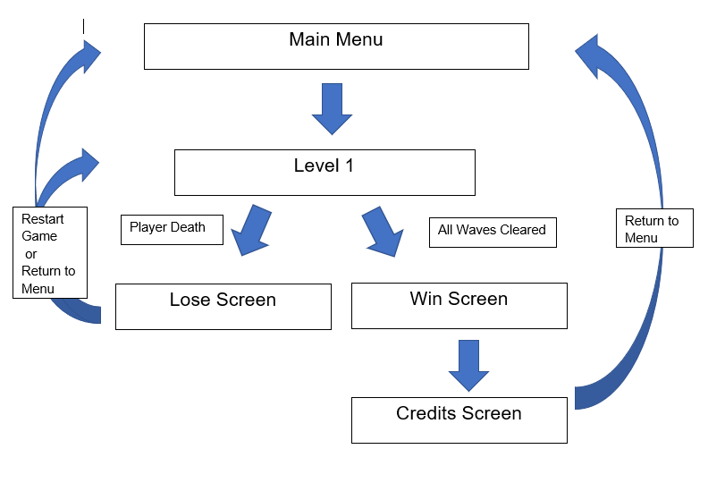

# 10 Game Play

## 10.1 Game Controls

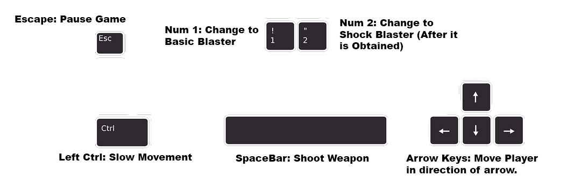

## 10.2 Game Camera

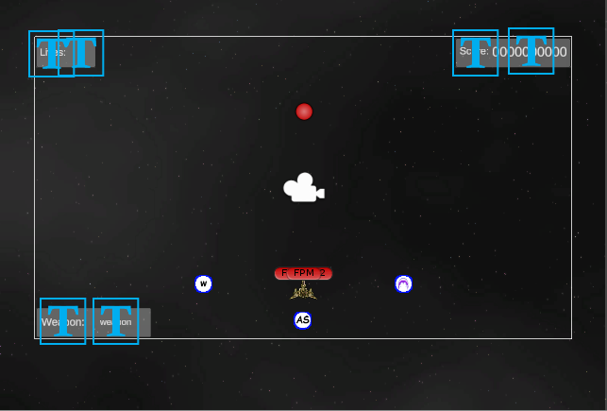

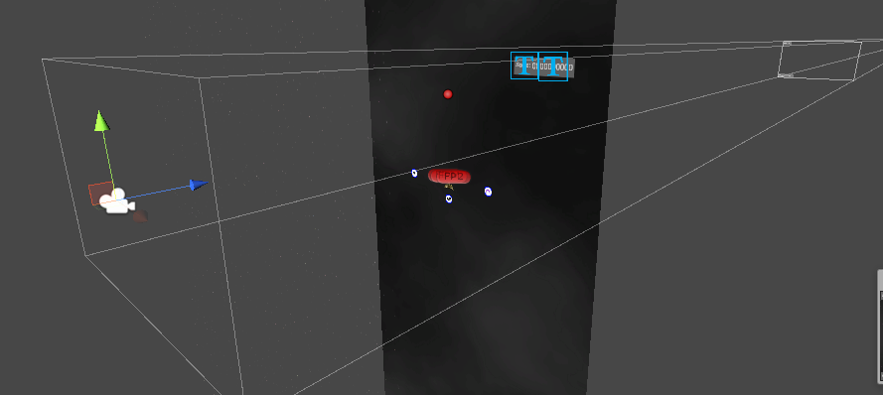

There is only one camera in the game and is projected orthographically in a 2D space. It is static, and the rectangular area it encloses defines the area in which the player can move. Movement through the “space environment” is just a background moving in a loop.

### 10.2.1 HUD

**Main In-Game**

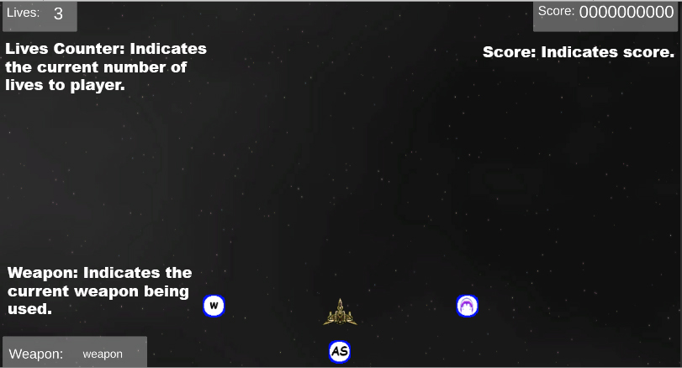

The main HUD that the player will be seeing.

**Game Paused**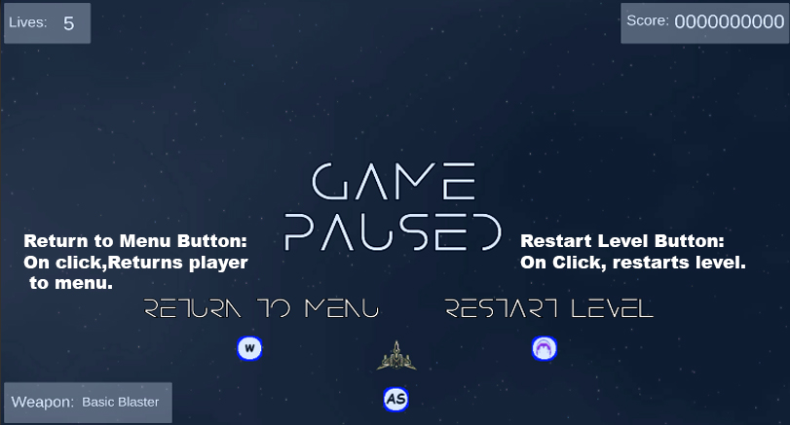

Indicates to the player that the game is paused once the escape button is pressed.

**Game Over**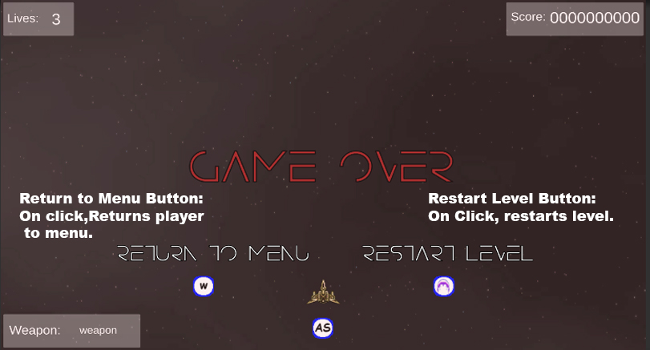

When Players lives reaches 0, this is the screen they will see after the player death.

**Level Win**

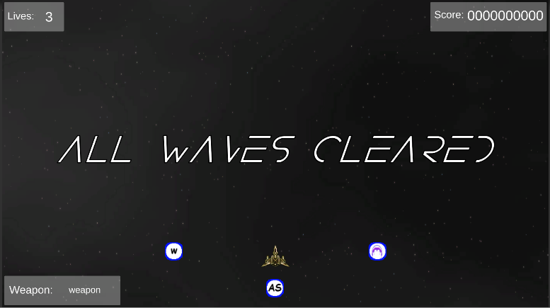

When the player defeats the level boss, the “All Waves Cleared” will show up on screen and will automatically lead the player to the next part of the game.

# 11 Players

## 11.1 Character

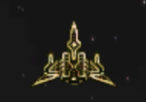There is only one character that is set by default. This is the sprite of the default character that the players will be using.

## 11.2 Metrics

Lives: 5 (Default)

Speed: 2.5 (Normal), 1.5 (Slow)

Damage: Depends on weapon and damage upgrade modifier (1.0 Base).

Attack Speed: Depends on weapon and AS upgrade modifier (1.0 Base).

## 11.3 States

**Player Idle**



When the player is not dead or hit, this is the sprite that shows.

## 

**Player Invincible**



When the player is hit, the sprite starts to blink indicating that the player is in a state of invincibility for five seconds. In this invincible state, players must get out of the way of being hit by any more bullets.

**Player Death**

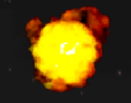When Player lives reaches 0, their sprite explodes,

Indicating a game over.

## 11.4 Weapons

**Basic Blaster**

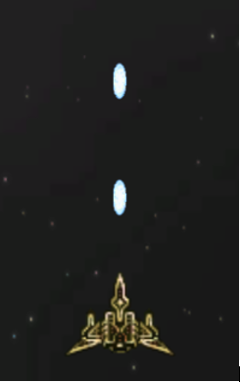The first weapon that the player can get. Weapon is indicated by blue bullet sprites. The Basic Blaster has low damage, but a fast fire rate.

Damage: 10 (Base) * Attack Damage Modifier

Attack Speed: 20 (Base) * Attack Speed Modifier

**Shock Blaster**

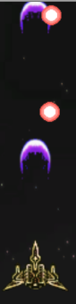The second weapon that the player can get. Weapon is indicated by purple waves bullet sprites. The Shock Blaster has a high damage output, but low fire rate.

Damage: 25 (Base) * Attack Damage Modifier

Attack Speed: 10(Base) * Attack Speed Modifier

## 11.5 Upgrades/Pickups

**W-Shot Upgrade**



An upgrade when picked up will allow weapons to be fired in a W-Shot.

Modifier: Weapons allow W-Shot.

**Attack Speed Upgrade**



An upgrade when picked up will increase the attack speed of weapons.

Modifier: +0.5 AS

**Shock Blaster Pickup**



A weapon pick up that will allow the use of the shock blaster.

# 12 NPC

## 12.1 Enemies

**Enemy Grunt**



The basic enemy of the first level. Has two patterns of shooting a basic single w-shot and a burst fire w-shot.

Health: 750

Move Speed: 1

Score: 200

**Enemy Boss**

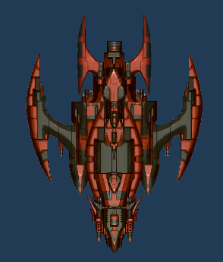The boss of the first level. The boss has three patterns of shooting, however, it will sometimes combine those patterns by shooting both at the same time.

Health: 70,000

Move Speed: 2

Score: 20,000

### 12.1.1 Enemy States

**Enemy Spawn**

Upon being instantiated, the enemy will move straight into the camera’s view at a certain indicated point. The enemy will not shoot until it is aligned to this point. The enemy will then switch states to the Enemy Move and Shoot state.

**Enemy Move and Shoot**

This state is achieved once the enemy is aligned to the specified point. The enemy will oscillate left and back to its original position, or right and back to its original position depending on a certain integer value on spawn. At the same time, the enemy will shoot bullets at their fire point with a random bullet pattern.

**Enemy Death**

Upon reaching zero health, the enemy will be destroyed. Before being destroyed, the enemy will play a death explosion animation that is similar with the player death animation. The explosion is bigger for bosses.

### 12.1.2 Enemy Spawn Points

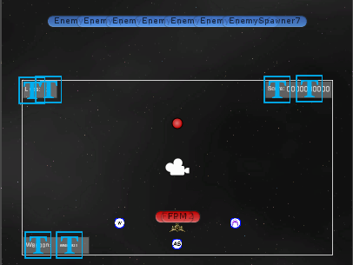

The enemy will spawn from seven different points outside of the play area. Grunts will always spawn randomly from these seven points, but bosses will always spawn in the middle as bosses will be bigger than normal enemies. As mentioned, as soon as the enemy spawns, they will move to a point indicated by the red dot.

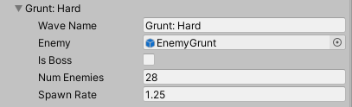

Enemies will spawn wave by wave, with differing number of enemies, at a rate specified by a float value.

### 12.1.3 Enemy Bullet Patterns

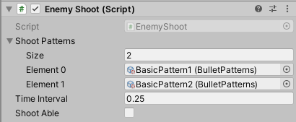

Every enemy will have an array of bullet patterns and the pattern they choose depends on a random integer value.

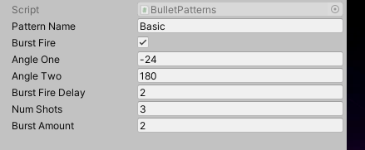

The bullet patterns are a scriptable object with different values. A burst fire toggle to indicate that the pattern will be shot a number of times, two angles to define the trigonometric area the enemy will shoot at, a burst fire delay for the fire rate of the burst fire toggle, the number of shots indicating how many bullets that will be fired along the trigonometric area, and a burst amount indicating the amount of times you want to fire the shots.

# 13 Art

## 13.1 Direction

Because the game takes place in space and the genre is a classic arcade shmup, the game’s art direction will move towards a kind if a futuristic look with 16-bit sprites. To get to this direction, assets that give off a futuristic and war-torn vibe with a classic 16-bit arcade look were chosen. All assets were taken from opengameart.com.

## 13.2 Sprites

**Moving Background**

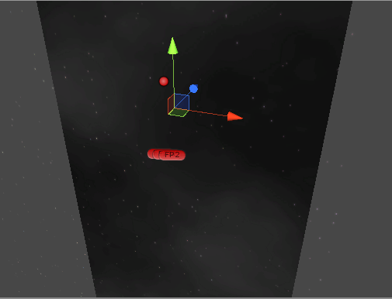

The background is made of two assets, a repeating image of clouds in a dark background and glowing stars right above it. Adding these two assets together creates a deep space ambience. Furthermore, the background moves upwards in a loop direction in order to simulate the effect that the player is moving through space, when the player is mainly static.

**Bullet Sprites**

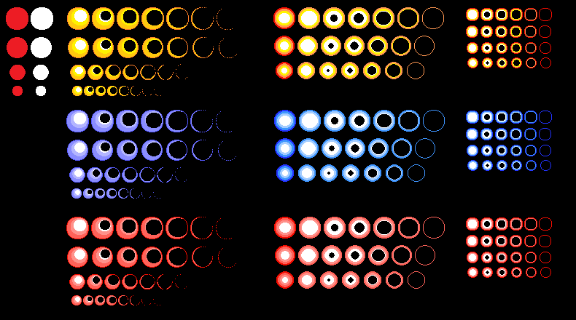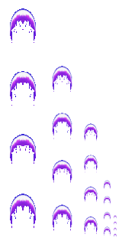

The bullet sprites of Alpha One are of the 16-bit style. To distinguish between player weapons and enemy bullets, enemy bullets are of the red color and player bullets are blue or use a different bullet sprite. Red is usually associated with indicating danger or someone of the opposing force, while blue gives of a more friendly tone. This is the reason these colors were chosen.

**Player/Enemy Sprites**

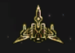 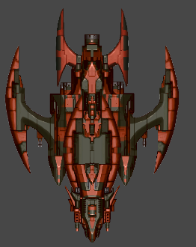 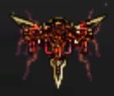

The jet fighter sprites of Alpha One give off a futuristic ambience with the pointy silhouettes and modern look. The player sprite is a simple brass colored jet. To distinguish the enemies from the player, red organic matter is placed on the original player sprite to indicate danger and to also fit the synopsis of Alpha One with an infectious disease spreading through the galaxy. The boss sprites of Alpha One are very large, and almost take up half the screen. The size of the sprite matters as making the enemy bigger indicates to the player that it is a boss and is more dangerous than other enemies.

## 13.3 Audio

Most of the gameplay is discerned through visual feedback. The player got hit, so the player’s sprites begin to blink. The enemy is hit, so the bullets have an explosion effect upon impact.

Because of this, the only audio is just background music on loop so that the game does not feel plain. The background music chosen needed to be something that fits the theme of the future, yet at the same time feels exhilarating. The music that would fit the criteria would be a psychedelic trance song, more specifically *Old Gods by Seven Lions, Abraxis, Dimibo*. Old Gods gives an epic feel as if you are facing a deity with the deep religious chants in the background, supplemented by the thump of deep war drums. At the same time, the song features futuristic electronic synths to fit the modern technological feeling.

# 14 Procedurally Generated Content

## 14.1 Levels

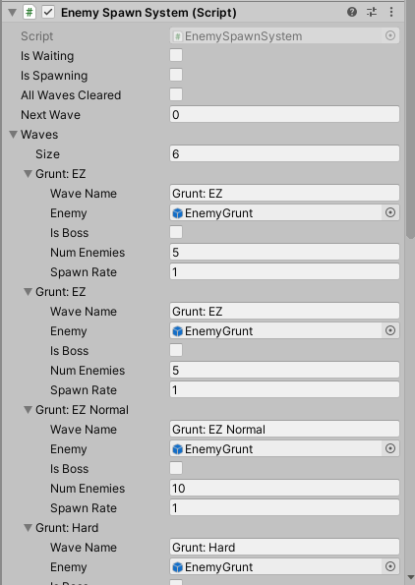

Levels in Alpha One are of the same structure. The player spawns in a closed environment while enemies shoot bullets at the player and spawn in waves, and at the end of the wave, the boss appears. Overall, levels are made for the player to survive in. In order to achieve this type of level design, an enemy wave spawn script is used. How this script works is that an array of objects of type wave are linearly and orderly traversed, and the current wave is pointed to by an index, *Next Wave*. The wave contains information such as the name, the type of enemy that spawns, the number of enemies, and the spawn rate of these enemies. To reach the next wave, all enemies must be destroyed, and this is done by checking if objects of the tag enemy are present. This check is done at an interval. When a wave is being spawned in, the state of the system changes to *isSpawning* indicating it is spawning enemies. If all enemies are spawned, the state of the spawn system changes to *isWaiting* and that it is checking to see if all enemies are destroyed. Once the Next Wave variable goes over the size of the array of waves, the state of the system changes to all waves cleared indicating the finish of the level.

## 14.2 Minimum Viable Product (MPV)

* Built for the PC platform
* One level
* One type of enemy
* One type of boss
* One type of weapon

# 15 Wish List

**ADD MORE LEVELS**

Currently there is one test level in the game, and more levels would add more length to the game.

**ADD MORE ENEMIES**

There are currently only one type of enemy grunts and one enemy boss. Adding more enemies will lessen the monotonous nature of facing the same enemy multiple times.

**ADD UPGRADE SHOP**

Instead of making upgrades drop from enemies, it would be better to add a shop that converts score into currency at the end of each level.

# 16 Bibliography

|  |  |  |
| --- | --- | --- |
| Type of Asset | File Name | Source |
| Sprite | BasicBlasterBullet_Hit.png | <https://opengameart.org/content/explosion-set-1-m484-games> |
| Sprite | bullet.png | <https://opengameart.org/content/dark-moon-inc-stuff> |
| Sprite | Damage.png | <https://opengameart.org/content/dark-moon-inc-stuff> |
| Sprite | EnemyBulletSprite.png | <https://opengameart.org/content/explosion-set-1-m484-games> |
| Sprite | MeagaLaser.png | <https://opengameart.org/content/dark-moon-inc-stuff> |
| Sprite | ShockBlasterBullet.png | <https://opengameart.org/content/dark-moon-inc-stuff> |
| Sprite | ShockBlasterBullet_Hit.png | <https://opengameart.org/content/explosion-set-1-m484-games> |
| Sprite | Speed.png | <https://opengameart.org/content/dark-moon-inc-stuff> |
| Sprite | Wpn1.png | <https://opengameart.org/content/dark-moon-inc-stuff> |
| Sprite | Wpn2.png | <https://opengameart.org/content/dark-moon-inc-stuff> |
| Sprite | BossExplosion.png | <https://opengameart.org/content/explosion> |
| Sprite | exp2_0.png | <https://opengameart.org/content/explosion> |
| Sprite | M484ExplosionSet1.png | <https://opengameart.org/content/explosion-set-1-m484-games> |
| Sprite | Corrupted1.png | <https://opengameart.org/content/dark-moon-inc-stuff> |
| Sprite | Option.png | <https://opengameart.org/content/dark-moon-inc-stuff> |
| Sprite | REDBOSS.psd | <https://opengameart.org/content/spaceship-boss> |
| Sprite | Ships.png | <https://opengameart.org/content/dark-moon-inc-stuff> |
| Sprite | ASPowerUp.png | Original Design |
| Sprite | ShockBlasterPowerUp.png | Original Design + <https://opengameart.org/content/dark-moon-inc-stuff> |
| Sprite | wShotPowerUp.png | Original Design |
| Sprite | Clouds1.png | <https://opengameart.org/content/dark-moon-inc-stuff> |
| Sprite | Raindrops.png | <https://opengameart.org/content/dark-moon-inc-stuff> |
| Sprite | spr_stars01.png | <https://opengameart.org/content/stars-parallax-backgrounds> |
| Sprite | spr_stars02.png | <https://opengameart.org/content/stars-parallax-backgrounds> |
| Font | Disolve_light.ttf | <https://www.dafont.com/disolve.font> |
| Font | Disolve_regular.ttf | <https://www.dafont.com/disolve.font> |